Sri Lanka Institute of Information Technology

**User Experience Engineering - SE3050**

**Lab sheet 6**

**Suggest design improvements and get user feedback**

B.Sc. (Hons) in Information Technology

**Failed points - Design Sketches**

**IT19127538**

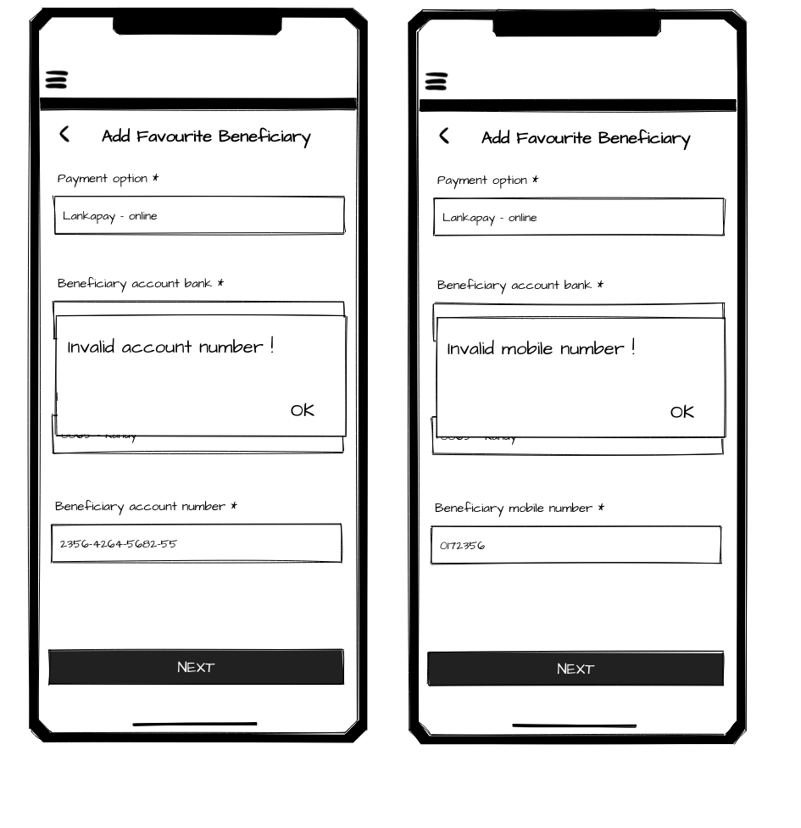

**IT19062266**

**Sign In**

|  |  |  |
| --- | --- | --- |
|  |  |  |

**Forgot Password**

|  |  |  |
| --- | --- | --- |
|  |  |  |

**IT19037998**

**One Time Transfer**

|  |  |  |  |
| --- | --- | --- | --- |
|  |  |  |  |

**Favorite Fund Transfer**

|  |  |  |  |
| --- | --- | --- | --- |
|  |  |  |  |

|  |  |
| --- | --- |
|  |  |

**Cheque Services**

|  |
| --- |
|  |

**IT19513188**

**Bill Payment**

**One Time Bill Payment**

|  |  |  |  |
| --- | --- | --- | --- |
|  |  |  |  |

**Favorite Bill Payment**

|  |  |
| --- | --- |
|  |  |

**Manage Favorite Bill and Device Management**

|  |  |  |  |
| --- | --- | --- | --- |
|  |  |  |  |
|  |  |  |  |

**Failed points – Wireframes**

**IT19127538**

**Manage Favorite Beneficiary**

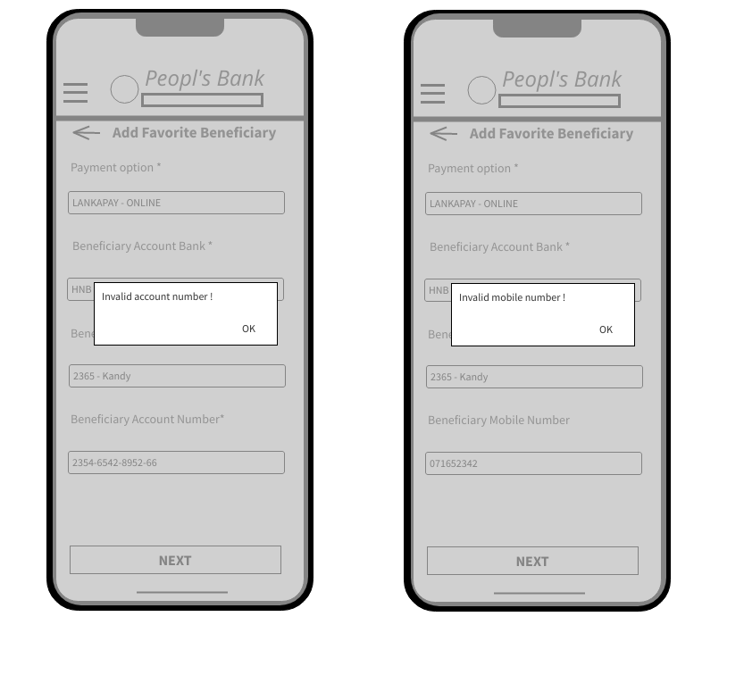

**IT19062266**

**Sign In**

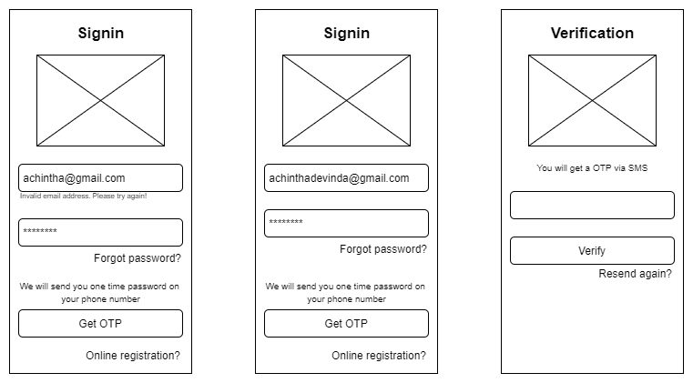

**Forgot Password**

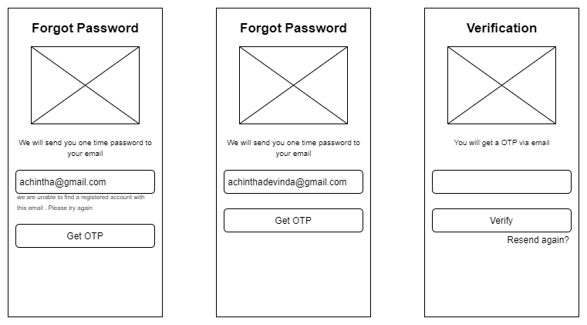

**IT19037998**

**One Time Transfer**

|  |  |  |  |
| --- | --- | --- | --- |
|  |  |  |  |

**Favorite Fund Transfer**

|  |  |  |  |
| --- | --- | --- | --- |
|  |  |  |  |

|  |  |
| --- | --- |
|  |  |

**Cheque Services**

|  |
| --- |
|  |

**IT19513188**

**Bill Payment**

**One Time Bill Payment**

|  |  |  |  |
| --- | --- | --- | --- |
|  |  |  |  |

**Favorite Bill Payment**

|  |  |
| --- | --- |
|  |  |

**Manage Favorite Bill and Device Management**

|  |  |  |  |
| --- | --- | --- | --- |
|  |  |  |  |
|  |  |  |  |

**Version - 1 Failed Prototype with Version -2 Corrected Prototype**

**IT19127538**

|  |  |
| --- | --- |
| Failed Prototype | Redesigned Prototype |
|  |  |
|  |  |

**IT19062266**

|  |  |
| --- | --- |
| Failed Prototype | Redesigned Prototype |
|  |  |
|  |  |

**IT19037998**

|  |  |
| --- | --- |
| Failed Prototype | Redesigned Prototype |
|  |  |
|  |  |

**IT19513188**

|  |  |
| --- | --- |
| Failed Prototype | Redesigned Prototype |
|  |  |
|  |  |
|  |  |
|  |  |

**Final Prototypes**

**IT19127538**

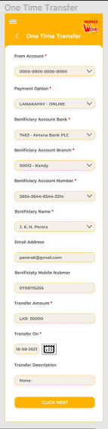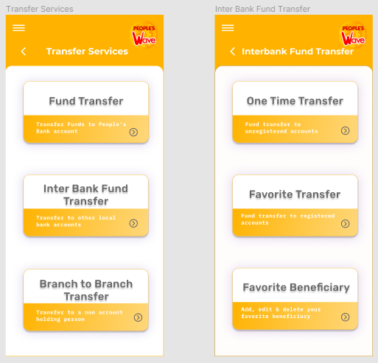

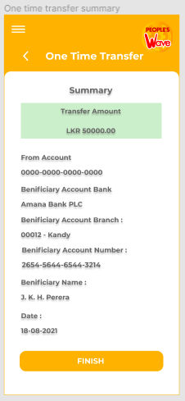

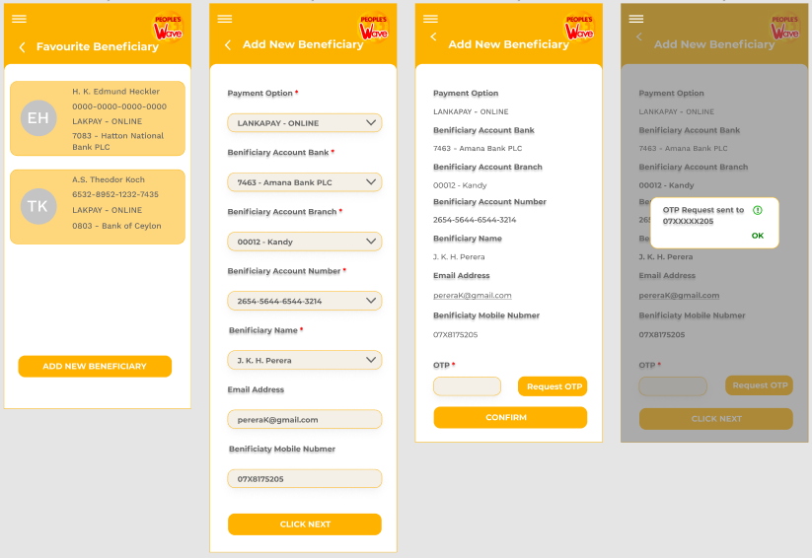

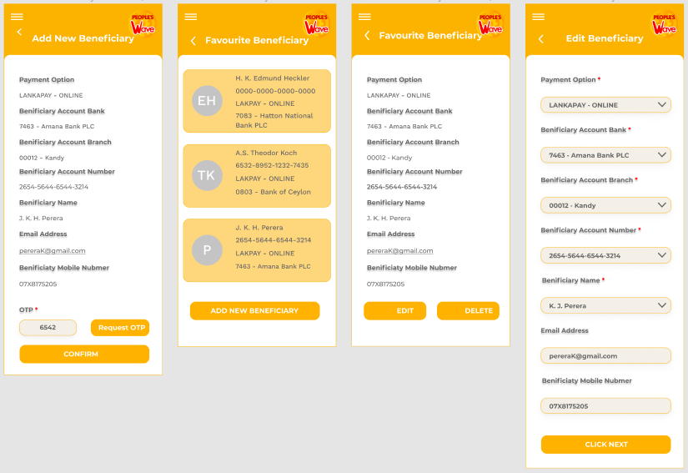

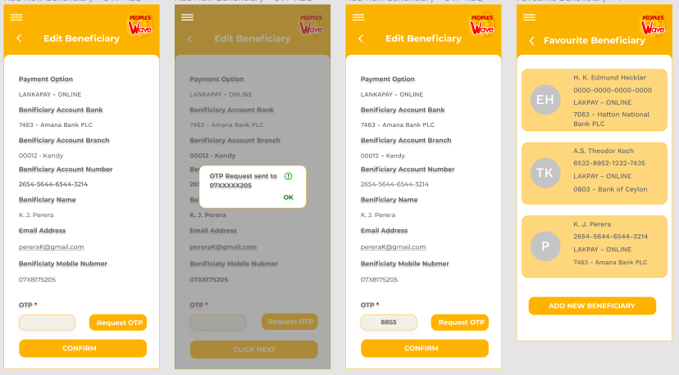

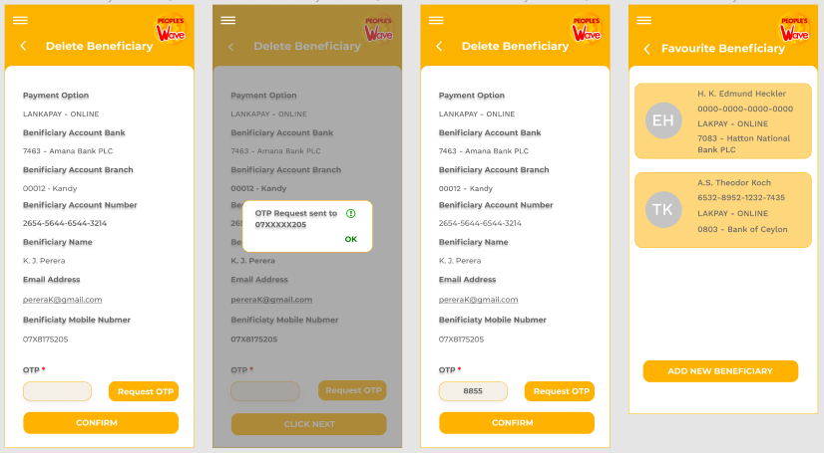

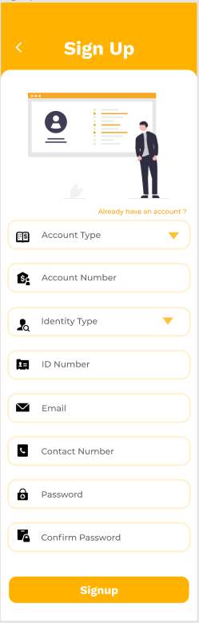**IT19062266**

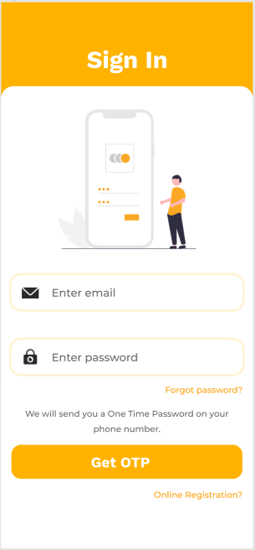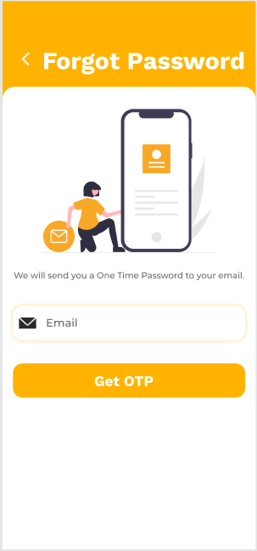

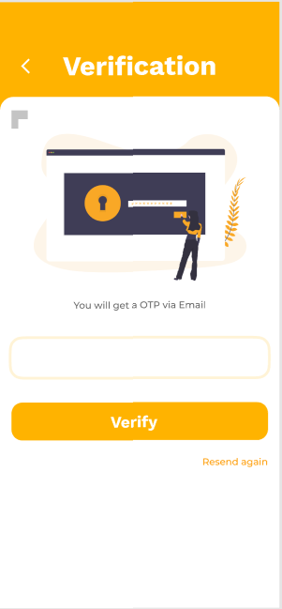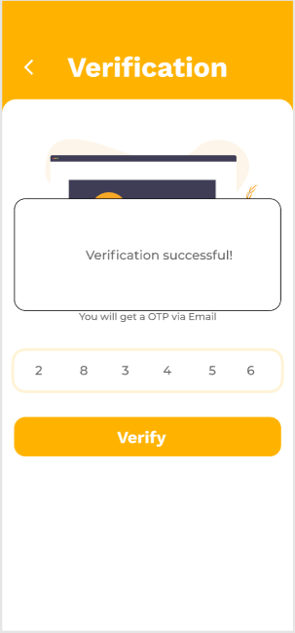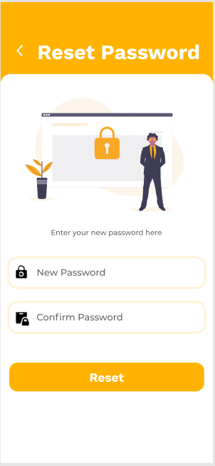

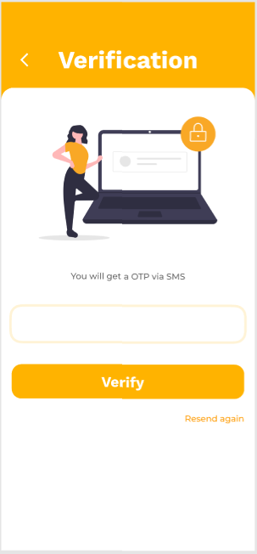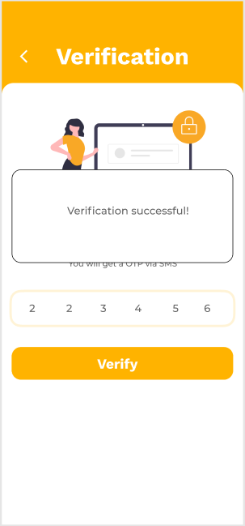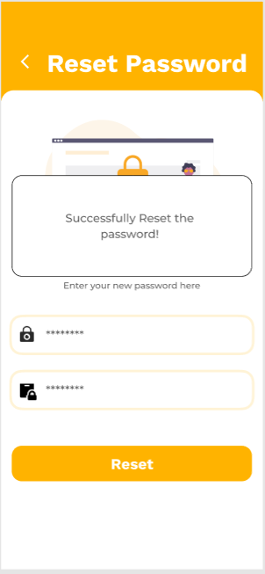

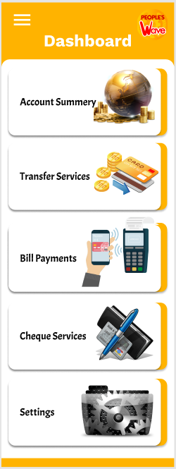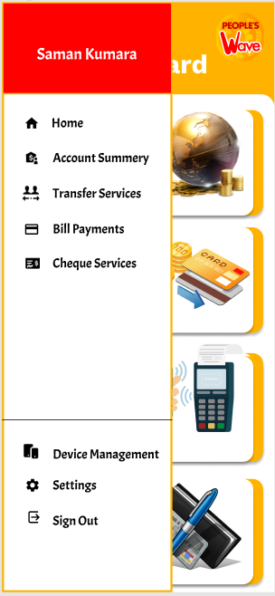

**IT19037998**

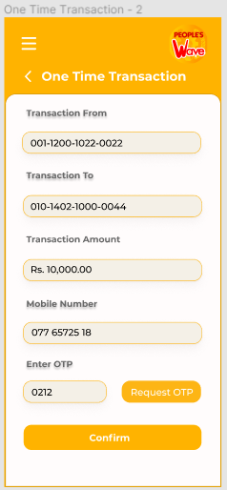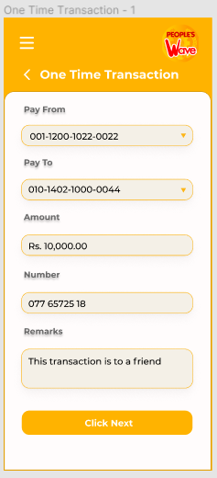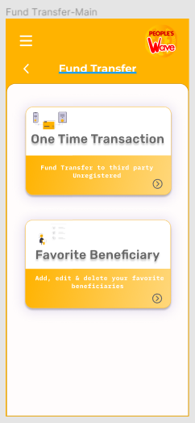

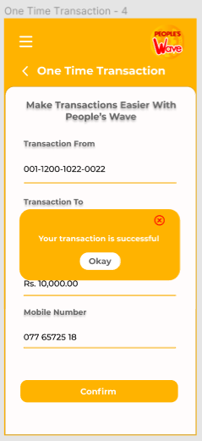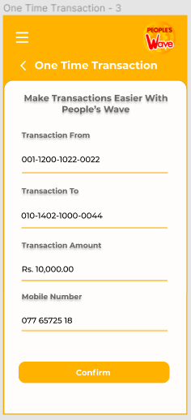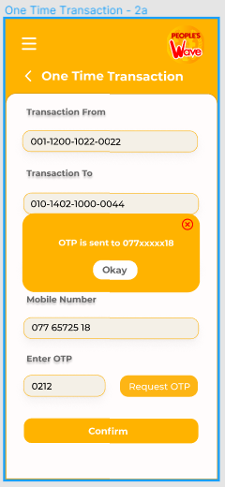

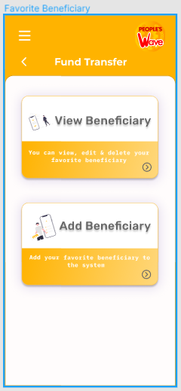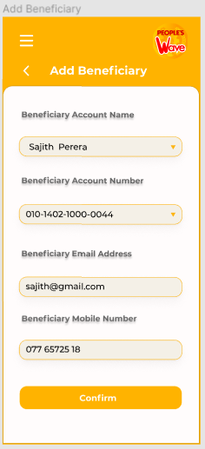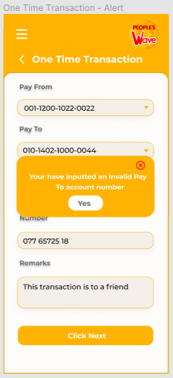

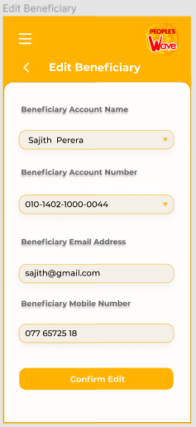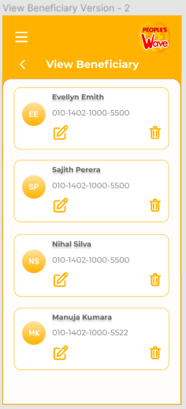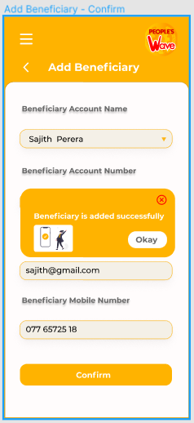

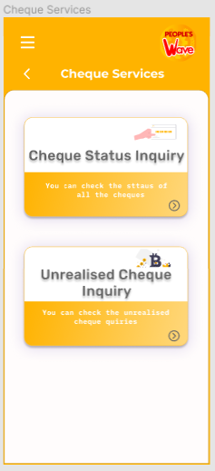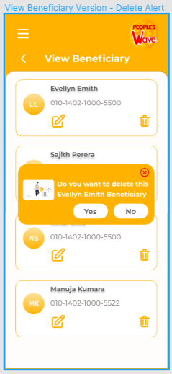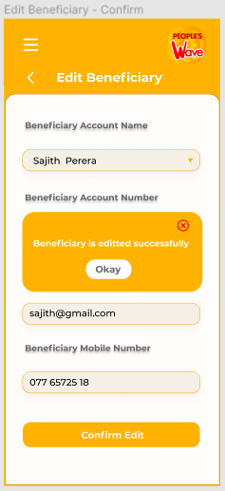

**IT19513188**

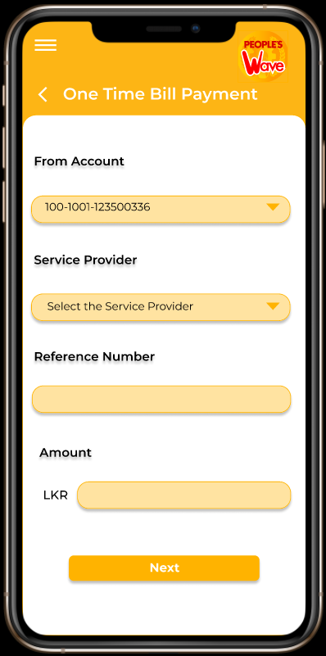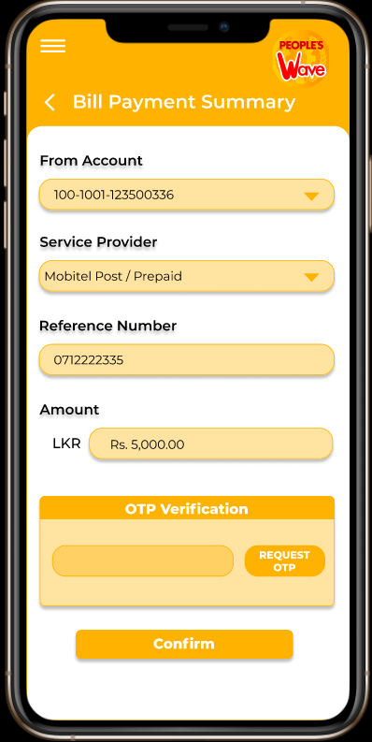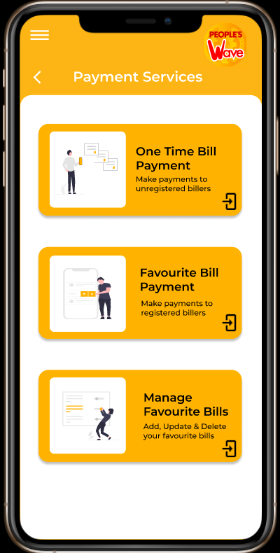

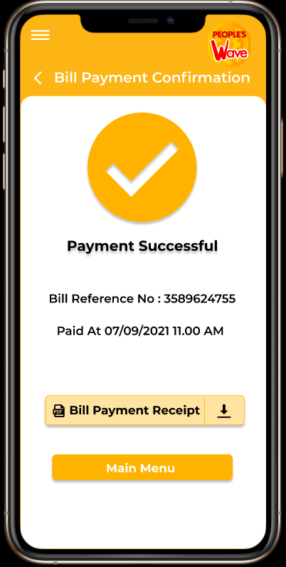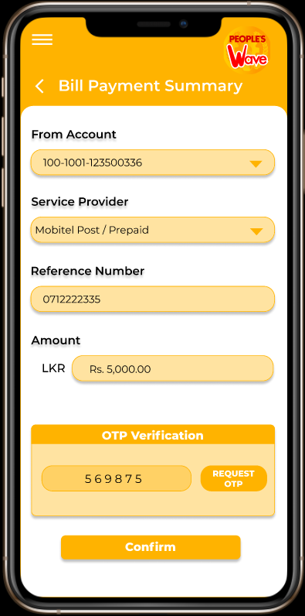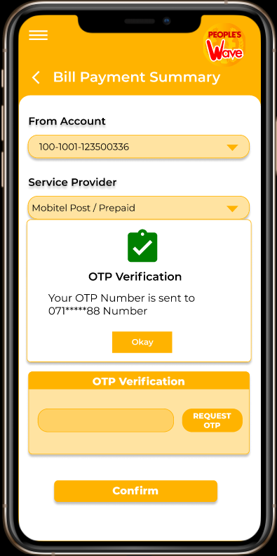

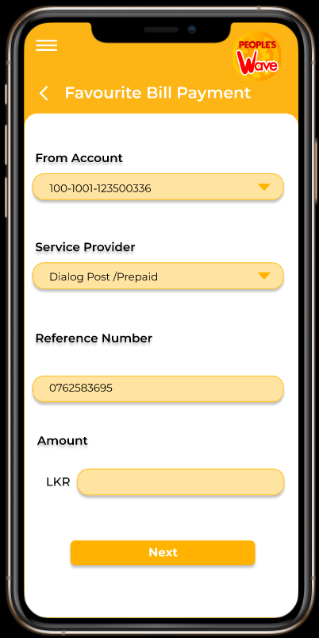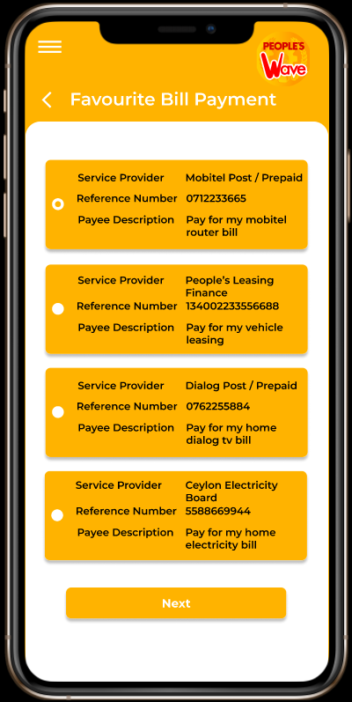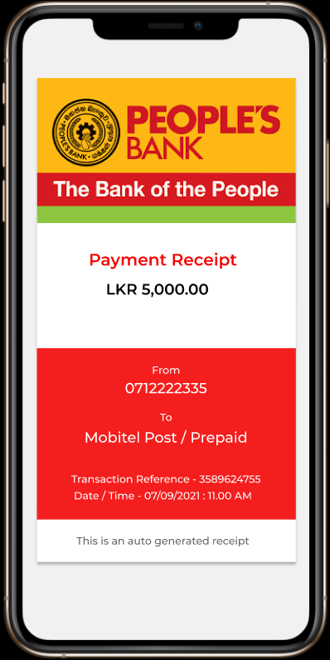

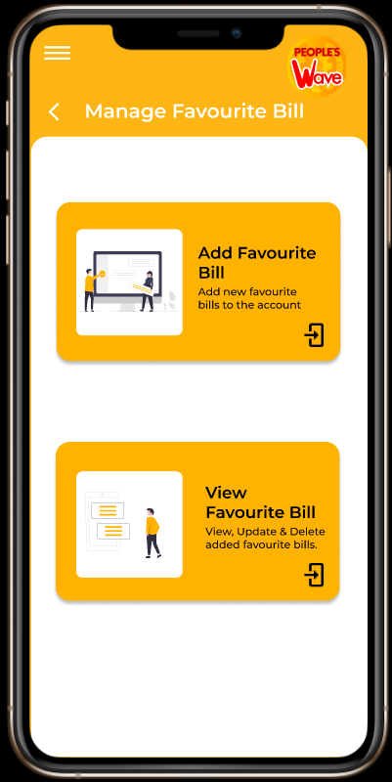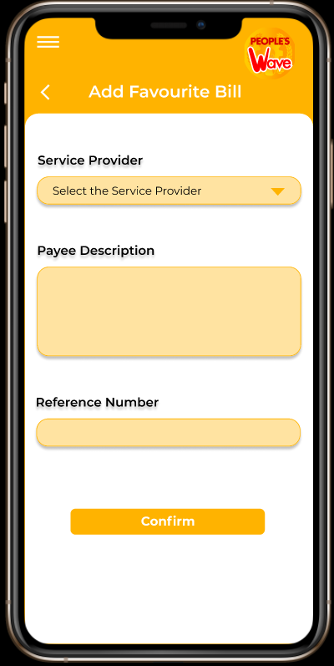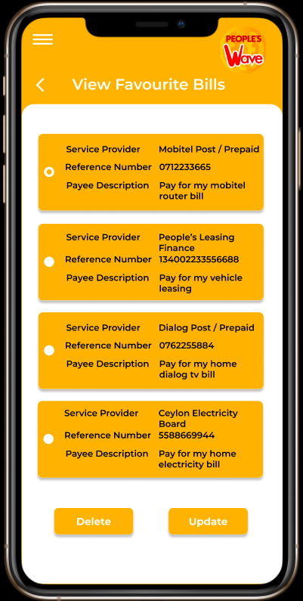

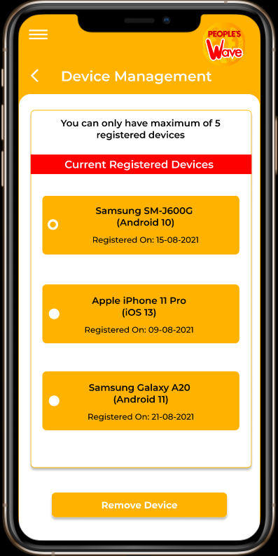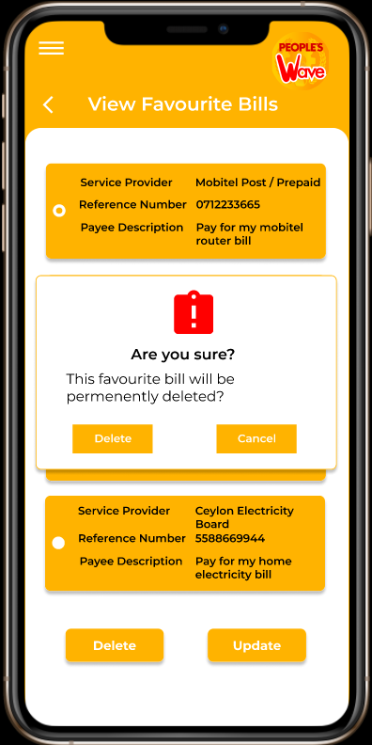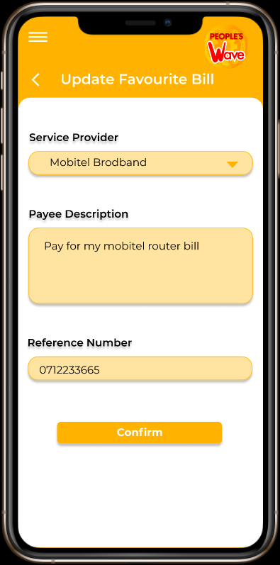

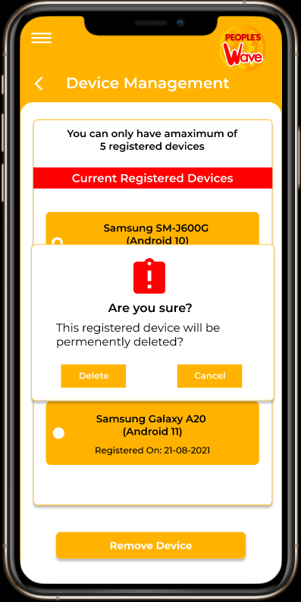

**Interview video link**

<https://web.microsoftstream.com/video/2df20f56-62a8-4b73-b452-becd6a411b45>

**Interview Scripts**

**Interview - 1**

Sidath: Hi everyone welcome back. We have recreated the interfaces which belongs to our functionalities as prototypes, So the main intention of this interview will be that introducing those interfaces to our users and getting the feedbacks from them to the respective prototypes. Here we go again with meeting Mr. Achintha. Hope everyone remembers him as well.

Sidath: Mr. Achintha, thank you again for taking the time to participate in this study.

Sidath: So, let’s start the interview….

Sidath: We are going to show you the recreated interfaces for each and every interface.

Sidath: So, let’s start from the login process

Sidath: So, this is the login page which we recreated, what do you think about this…

Sidath: This is the Sign-up page, so what are your thoughts on this?

Sidath: Thank you Sir. So, let’s move on to the forgot password page.

Sidath: Thank you again Sir.

Sidath: Now I am going to show you the Sign-in process…

Sidath: Okay sir. This is the dashboard. understand.

Sidath: Finally, what do you think about this navigational drawer.

Sidath: Thank you so much sir. That’s it from my side. Guy’s you all can continue with your interfaces.

Viraj: Hi sir. So, I know, going to show the interfaces which I recreated to my functionality. So, let’s start with the One Time Transaction.

Viraj: [...Describing the one-time transaction]. So, what do you think about this flow and user interfaces related to this one-time transaction?

Viraj: Thank you sir, so let’s move on favorite beneficiary section

Viraj: [...Describing the add beneficiary section]

Viraj: [...Describing the view beneficiary] So, sir what do you think about the interfaces.

Viraj: Okay sir sure.

Viraj: Hmm…Okay sir I will try to change that. Are there any other issues?

Viraj: Okay sir. I will also look into it. Thank you, sir, for the useful feedbacks. So that’s it from my section.

**Interview – 2**

Sidath: Hi everyone welcome back. We have recreated the interfaces which belongs to our functionalities as prototypes, So the main intention of this interview will be that introducing those interfaces to our users and getting the feedbacks from them to the respective prototypes. Here we go again with meeting Ms. Sachini, Hope everyone remembers her as well.   
Sidath: Ms. Sachini, thank you again for taking the time to participate in this study.

Sidath: So, let’s start the interview from the dashboard….  
Sidath: Ma’am what do you think about this interface.  
Sidath: Okay Thank you madam. This is the navigational drawer please give us your feedback about this.   
Sidath: No madam, it is just an avatar.   
Sidath: Okay, Thank you madam. Guy’s you can continue

Dananjaya: Good evening, Madam, we have made some adjustments and recreated the interface, let’s move in to the interfaces…  
Dananjaya: Madam can you see the interfaces.   
Dananjaya: [...Describing the interbank one-time fund transfer process]  
Dananjaya: What are your thoughts in these interfaces?   
Dananjaya: Okay thank you madam.  
Dananjaya: Let’s move in to the manage favorite beneficiary  
Dananjaya: [...Describing the manage favorite beneficiary], what are your thoughts on these?   
Dananjaya: Okay Madam, thank you for your valuable feedback and that’s it from my part, you guys can continue with your functionalities.

Yathushan: Good evening, Ma’am. We have recreated the interfaces of the people’s wave mobile application with some modifications. Initially I will explain each process at the end you can give your feedback at the end of each process.   
Yathushan: [...Describing the One Time Bill Payment section]  
Yathushan: So that’s all from the onetime payment section, so are there any failures in the UI’s  
Yathushan: Okay Ma’am. [...Describing the favorite bill payment section]  
Yathushan: So that’s all from the favorite bill payment section, so are there any failures and faults in the UI.   
Yathushan: Okay Ma’am noted. [...Describing the manage favorite bill part and the device management]  
Yathushan: So that’s all from the manage favorite bill section and device management section, so are there any failures and faults in the UI.   
Yathushan: Okay Ma’am noted that’s all from me. Thank you

**Individual Contribution**

|  |  |  |
| --- | --- | --- |
| **Registration No.** | **Name** | **Contribution** |
| IT19127538 | A.R.W.M.B.W.D.B. Jayawardhana | Designing Inter-Bank transaction,   * Prototypes * Sketches * Wireframes * taking respective Screenshots   Completing the report |
| IT19062266 | S.W.R.S.I. Rathnayake | Designing sign in, sign up, forgot password, dashboard navigational drawer,   * Prototypes * Sketches * Wireframes * taking respective Screenshots   Creating the interview video |
| IT19037998 | A.V. Joachim | Designing Fund transaction,   * Prototypes * Sketches * Wireframes * taking respective Screenshots   Writing the interview script. |
| IT19513188 | K.A. Yathushan | Designing Bill payments and Device management,   * Prototypes * Sketches * Wireframes * taking respective Screenshots   Linking all Prototypes version 1 and version 2. |